**Superior University Faculty of CS & IT**





Task 9

Computer Network Lab

**Submitted by:** Iqra Khawar

**Submitted to:** Sir Rasikh Ali

**Section:** 5B

**Semester:** 5th

**Submission Deadline:** 10-12-24

**Program:** SE

**Roll no:** su92-bssem-f22-307

**Department of Software Engineering**

**Task 1;**

**Different Between “Sub-Netting & Super-Netting”, with Example (draw structure in cisco)**

***Super-netting is the opposite of Sub-netting.***

In sub-netting, a single big network is divided into multiple smaller subnetworks. Whereas, in Super-netting, multiple networks are combined into a bigger network termed as a Super-network or Super-net.

**Subnetting**

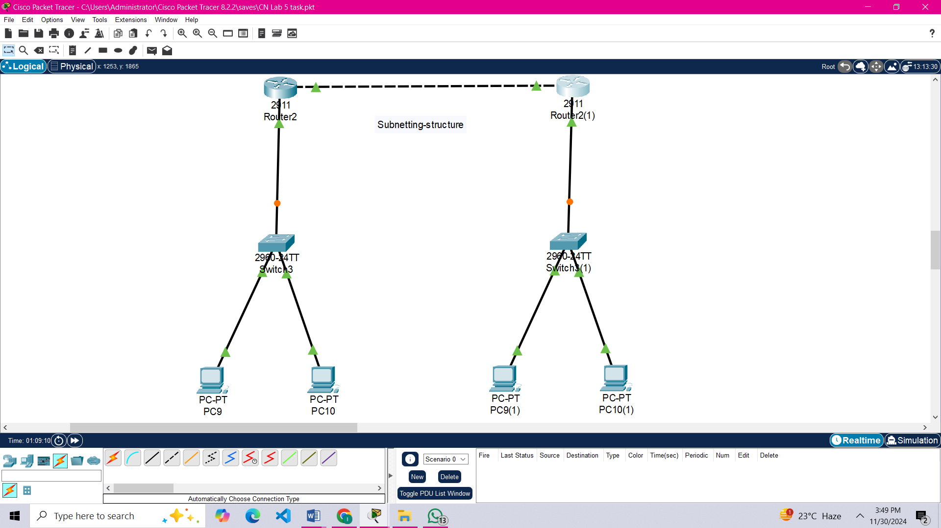

**Super-netting**

